August 28, 2015
Women in Business 2015: Eliza Solender, President, Solender/Hall Inc.
From transforming a former bowling alley into the Dallas Children’s Theater, a doctor’s office into one of Dallas’ top-rated restaurants and a church publication’s office into the SPCA’s new home, Eliza Solender has helped shape the face of North Texas.
Founded in 1991, boutique commercial real estate company Solender/Hall Inc. specializes in representing nonprofit organizations and small- to medium-sized companies in the North Texas area.
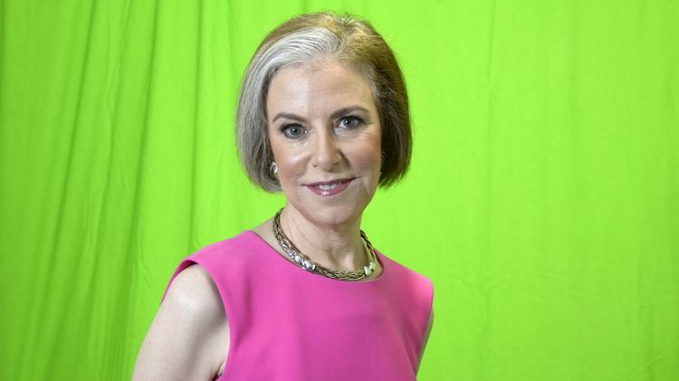Enlarge
Eliza Solender, President, Solender/Hall Inc.
Jake Dean
Best known for their nonprofit work, the certified woman-owned business has worked on hundreds of nonprofit real estate projects.
“I love ribbon-cutting ceremonies and hearing about the impact our efforts have had on the lives of people in our community,” Solender said.
Describe a moment that shaped your future. The day I met my husband. Boy, was I a lucky girl!
How has the corporate business world reacted to you as a woman business leader? Very well. For example, I serve on the board of directors of Community Trust Bank where I feel very respected and appreciated. It has been a wonderful experience.
Has that reaction changed over the years? It only gets better and better.
What do you anticipate for the future of women in business? The future looks very good. Women are assuming greater leadership roles in all industries. I think that bodes well for our economy.
What advice would you give to young women starting their careers in your industry? I tell each one to get her broker’s license (gives you the freedom to walk out the door and work for yourself); save at least two to three years of living expenses because our industry always has down cycles; pay off your credit card debt (and as quickly as possible your mortgage); and never drive a car that is nicer than the one driven by your boss.

Solender/Hall Inc.
Address: P.O. Box 670009, Dallas 75367-0009
Revenue: Did not disclose
Employees: 3 core members with numerous contractors and consultants
Phone: 214-265-8200
Web: solenderhall.com

http://www.bizjournals.com/dallas/print-edition/2015/08/28/women-in-business-2015-eliza-solender-president.html?ana=e_dal_rdup&s=newsletter&ed=2015-09-30&u=kXCEwLitM4yyjMBnaxFDwUI82m1&t=1443624634

